A Simplified Approach to Security Event Management
Indhuja.E
Department of Computer Science and Engineering
Kalasalingam Academy of Research and Education,
Krishnankoil-626126.
Tamil Nadu, India.
indhuja@klu.ac.in

G Venkat
Department of Computer Science and Engineering
Kalasalingam Academy of Research and Education,
Krishnankoil-626126.
Tamil Nadu, India.
99220041180@klu.ac.in
P Ajay kumar Reddy
Department of Computer Science and Engineering
Kalasalingam Academy of Research and Education,
Krishnankoil-626126.
Tamil Nadu, India.
99220040689@klu.ac.in

Ch Eswar
Department of Computer Science and Engineering
Kalasalingam Academy of Research and Education,
Krishnankoil-626126.
Tamil Nadu, India.
99220041152@klu.ac.in
P Roopananda Reddy
Department of Computer Science and Engineering
Kalasalingam Academy of Research and Education,
Krishnankoil-626126.
Tamil Nadu, India.
99220040674@klu.ac.in

Abstract— This paper presents the design and development of a Mini Security Information and Event Management (SIEM) system built using Python Flask. The system aims to show how basic security monitoring can be done through log collection, rule-based detection, and alert generation. It allows users to upload log files, detect unusual activities such as failed logins or large data transfers, and view alerts on a web dashboard. The project focuses on creating an easy-to-understand model that explains SIEM concepts in a simple way for students and beginners. Key features include data storage with SQLite, real-time alert display, simulation mode, and a learning-based game for user awareness. The system helps in understanding how events are processed and how simple rules can detect common threats. This work supports educational and research goals by making security monitoring more practical and interactive.
Keywords— SIEM, Flask, Log Analysis, Security Monitoring, Threat Detection, Web Application.

Introduction
Security Information and Event Management (SIEM) systems are important tools used to collect, analyze, and manage security events in real time. In most organizations, large and complex SIEM tools are used to monitor suspicious activities and detect possible threats. However, these systems are often expensive and hard to understand for students or beginners who want to learn how basic security monitoring works. To address this gap, a simplified and educational Mini SIEM system has been developed using Python Flask to show how log analysis and alert generation can be implemented in a clear and practical way.
The main aim of this project is to create a lightweight and interactive SIEM platform that helps users understand how security events are captured and analyzed. The objectives include building a web-based dashboard for log uploads, creating rule-based detection methods for identifying threats, and generating alerts based on unusual activities such as multiple login failures or large data transfers. The system also focuses on improving user awareness by including simple educational and fun features.

The project work includes designing a web application that allows users to upload CSV or JSON log files, process them using predefined detection rules, and display real-time alerts on the dashboard. The detection process uses simple conditions such as data transfer size, time of activity, or failed login attempts to identify suspicious events. The database is managed using SQLite for easy data storage and retrieval. The project also includes a “Find the Intruder” game and simulation mode to make the learning process more engaging.
To achieve the best results, the system was tested using sample log data covering normal and suspicious user behaviors. The rule-based detection method provided accurate alerts and clear visualization of events on the dashboard. The use of Flask made the system lightweight and easy to deploy, while Chart.js improved the graphical display of data. Overall, the Mini SIEM system successfully demonstrates key security monitoring functions in a simple and educational way, helping learners understand real-world SIEM concepts more effectively.

Literature Survey
Ramalingam et al. [1] (2025) proposed an AI-enhanced SIEM system that integrates deep learning to improve threat detection. Their system focuses on automating alert generation and analyzing large log data efficiently. However, the system is complex and requires significant computational resources, making it difficult for students or small-scale environments to implement.
Velásquez et al. [2] (2025) evaluated SIEM-SC for compliance and sustainability in security management. They focused on integrating policies and reporting for regulatory purposes. The limitation of this approach is that it primarily emphasizes compliance rather than real-time threat detection, limiting its practical security monitoring effectiveness.
Khayat et al. [3] (2025) developed an advanced alert management system using ensembles of deep learning models and hybrid optimization. While the approach improves detection accuracy for large-scale systems, it is resource-intensive and not suitable for educational or lightweight setups.

Sriram et al. [4] (2025) enhanced identity and access management in event systems using blockchain. Their work strengthens security for digital identities but adds complexity and deployment overhead, which can be a challenge for small organizations or research environments.
Banati [5] (2025) explored SIEM use cases for 5G networks, focusing on vulnerabilities and attack detection. The limitation is that their approach is highly specific to 5G, which reduces general applicability for other network environments.
Valladares and Ticona [6] (2025) implemented a SIEM system with alert automation to strengthen cybersecurity. While effective, their solution requires advanced configuration and is not easily accessible for learning purposes.
Mugeshwaran et al. [7] (2025) proposed an integrated AI-based SIEM system combining multiple detection techniques. Though robust, the system demands high computational power and complex tuning, limiting adoption in educational settings.
Samborskyi and Peleshok [8] (2025) focused on logical-dynamic SIEM designs for computer security. Their work is theoretical and emphasizes system design principles, which limits practical demonstration of real-time alerting.
Bulgakova et al. [9] (2025) analyzed explainable AI methods in SIEM. The study enhances interpretability of alerts but depends on complex AI models, which may not be suitable for lightweight educational implementations.
Cate [10] (2025) discussed cloud-based SIEM for national threat detection, highlighting its strategic importance. However, reliance on cloud infrastructure introduces cost and dependency issues, limiting deployment in offline or small-scale setups.
Gadicha et al. [11] (2025) explored deep learning for advanced threat detection in SIEM. Their approach improves detection accuracy but requires large datasets and computational resources, making it challenging for small or academic use.
Joshi [12] (2025) studied wireless network infrastructure for event management, aiming to optimize performance. While comprehensive, their work does not focus on threat detection or educational use.
Spence [13] (2025) highlighted the need for live event security risk management in a post-COVID-19 world. The study identifies practices but lacks practical implementation of automated alert systems.
Madani and Choudhry [14] (2025) examined spatial design to enhance safety in events. Their work focuses on physical safety rather than digital monitoring or alert generation.
Μηλιώνης [15] (2025) implemented a SIEM system with integrated XDR for host and network monitoring. Although comprehensive, the system is designed for enterprise-level deployment and may not be accessible for educational or small-scale projects.

Existing system
In most existing SIEM systems, the main focus is on enterprise-level solutions that handle large volumes of data from multiple sources. These systems use advanced tools and high-end servers to collect, store, and analyze security events. Popular platforms like Splunk, IBM QRadar, and ArcSight provide powerful dashboards and complex analytics to detect threats in real time. However, these systems are designed for large organizations and require skilled professionals to configure and manage them. They are also costly and need continuous maintenance, making them less suitable for small projects, students, or research purposes.
Another limitation in existing systems is their lack of educational support for understanding basic SIEM operations. Most commercial tools work like “black boxes,” where users can see alerts but cannot easily understand how those alerts are generated. The complexity of configuration, rule creation, and integration with other tools makes it difficult for beginners to learn the core concepts of event detection and analysis. This limits their use in training or academic environments.
Table.1-Previous Methodology
Aspect | Limitations
Complexity | Needs skilled professionals
Cost | Expensive for small projects
Transparency | Alerts are like black boxes
Educational Support | Hard to learn core concepts
Hardware Dependency | Requires heavy servers or cloud resources
Table 1 highlights the main features and limitations of existing SIEM systems.
Furthermore, many existing SIEM systems depend on heavy hardware and cloud resources to process large datasets, which can slow down performance in limited environments. They also do not offer built-in simulation or interactive learning modes to help users test and visualize different attack scenarios. Due to these limitations, there is a strong need for a simpler and lightweight model that can perform basic SIEM functions effectively while being easy to use, affordable, and educational.

Proposed Methodology
This section describes a clear and simple approach for the Mini SIEM. The system is built as a web app that takes log files, cleans and standardizes the data, looks for known patterns and thresholds that show risky actions, and then creates and shows alerts. The design also stores all events in a small database, shows charts and lists on a dashboard, and includes a simulation and game mode to help users learn. The goal is to keep the flow easy to follow, reliable in small setups, and useful for teaching basic security monitoring concepts.
Algorithm Used
The Mini SIEM uses a simple threshold-based event analysis algorithm designed to detect abnormal behavior in uploaded log data. Instead of relying on heavy or complex rule engines, this method focuses on comparing event values and patterns against common operational limits. It works on a clear, step-by-step flow to make it easy to understand, modify, and expand for different learning or research uses.
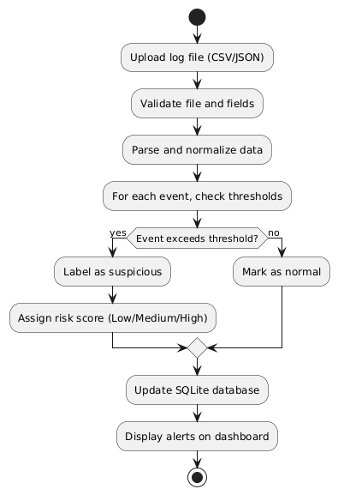
The algorithm begins by reading the cleaned and formatted log data from the upload module. The data in each record of the event is scanned and checked against the set limits, such as the number of failed login attempts, the total data size transferred, or the time at which the action took place. If any record exceeds the limit or falls within an unusual time frame, it is labeled as “suspicious.” The system provides a simple risk level (low, medium, or high) depending on how close the value is to the normal limit.
Fig.1-Algorithm Flowchart
Figure 1 above illustrates the algorithm flow of the Mini SIEM algorithm. In the algorithm, the log files that are uploaded are checked, processed, and analyzed based on the thresholds. Then, the activities are marked, scored, and stored in the database. Finally, the alerts are displayed on the dashboard, making it easy to analyze the activities.
The algorithm has a simple scoring system that helps in the identification of normal user activities and the activities that are considered to be suspicious. For example, the algorithm can be configured to mark the activities of two failed login attempts as “normal.” On the other hand, the algorithm can be configured to mark the activities of three or more failed login attempts in a short period of time as “medium.” Moreover, the algorithm can be configured to mark the activities of copying a file that is larger than 100MB in size to the external drive as “high.” Therefore, the algorithm can be considered to be simple and effective in the detection of security threats.
Finally, the SQLite database is updated, and the alerts are displayed on the dashboard. The algorithm can be considered to be fast in generating the alerts without the use of complex calculations, making it ideal for use in educational institutions. Moreover, the algorithm can be considered to be flexible and can be easily modified to accommodate the use of different types of log files and system environments. efficient, easy to maintain, and suitable for demonstrating core SIEM functions in a clear and simple way.
Methodology
Step 1 — Data collection and upload
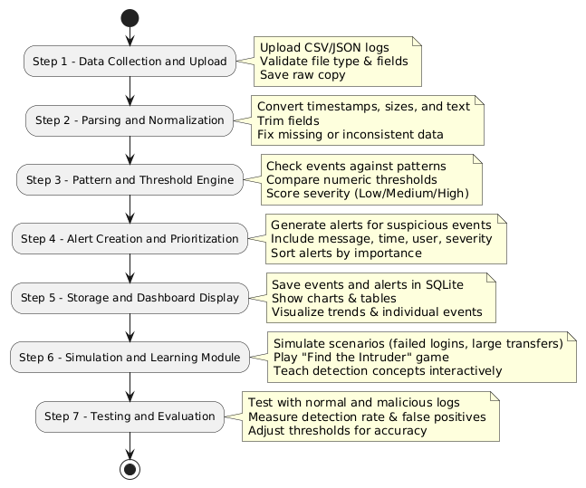
The users can upload the log files in CSV and JSON formats using the web interface. While uploading, the system will validate the file type and basic fields like timestamp, user, action, and source. The files will be stored in the upload folder, and a safe copy will be maintained before processing the files, so that the original data can be used for reference and running the test again.

Fig.2-Step Wise Methodology
Figure 2 below shows the steps involved in the Mini SIEM process. They include data upload and validation, parsing and normalization, pattern and threshold engine, and finally storing the data in a database.
Step 2 - Parsing and Normalization
After the data has been uploaded and validated, it is then normalized. This involves the data being read and normalized. For example, time is converted to a standard format, sizes and counts are converted to numerical format, and text data is trimmed. All the data is normalized in this step, and all the checks are performed in a standard format.
Step 3 - Pattern and Threshold Engine
The data is then analyzed in the pattern and threshold engine. This step checks the data and identifies any suspicious activities. For example, it checks for activities such as multiple failed logins in a short period of time, large files being transferred beyond a certain limit, and activities outside of normal hours. In this step, the data is scored based on severity using a set of criteria and basic rules. This makes it easy to see what is going on and to add rules to account for new scenarios.
Step 4 - Alert creation and prioritization
Once the engine has detected the suspicious event, it generates an alert. This alert consists of a message, a time stamp, a username, and a severity level. These alerts are stored in the database and displayed on the dashboard in such a way that the most important ones are displayed at the top.
Step 5 - Storage and dashboard display
All the events that are processed are stored in SQLite for future use. The dashboard displays the charts and tables representing the alerts, user actions, and sources in such a way that the user can easily understand the events that have occurred on the system. The user interface of the web server is also simple, ensuring that it works properly even on smaller servers and machines.
Step 6 - Simulation and learning module
The system also has a simulator that can be used to generate scenarios to test the system. For example, it can be used to simulate a number of failed logins and large transfers. The “Find the Intruder” game allows the user to play a log analysis game in which the user can select the suspicious log lines from a given list.
Step 7 - Testing and evaluation
The system can also be tested by analyzing the results generated from the log events. These are a number of normal and malicious events that have occurred on the system. It calculates the detection rate by counting the number of events detected by the system. These events can also be analyzed manually to check the proper functioning of the system.
Educational Objectives and Learning Outcomes
The Mini SIEM system is designed not only as a monitoring tool but also as an educational platform. The primary learning objectives include:
- Understanding the structure of security logs, including timestamps, user identifiers, and activity types.
- Learning how threshold-based detection mechanisms operate in practice.
- Observing the impact of false positives and false negatives in rule-based systems.
- Interpreting evaluation metrics such as accuracy, precision, recall, and F1-score.
- Practicing basic incident analysis through the simulation mode.
- Developing analytical thinking by identifying suspicious events in the “Find the Intruder” game.
Each module of the system supports these learning goals. The dashboard visualizes patterns and alerts, the simulation module generates controlled scenarios, and the interactive game reinforces understanding through active participation.

RESULTS AND DISCUSSION
We conducted a series of tests using the mini siem, and we fed it a mix of normal and abnormal activities in the logs. We aimed to find out how quickly the mini siem could recognize abnormal activities and send real-time alerts. In all the tests, the mini siem correctly recognized common security threats such as repeated failed login attempts, large data transfers to external devices, and activities performed outside normal business hours. The clean and intuitive interface of the dashboard made it easy to quickly grasp the activities performed, the time, and the user

.Fig.3-Dashboard
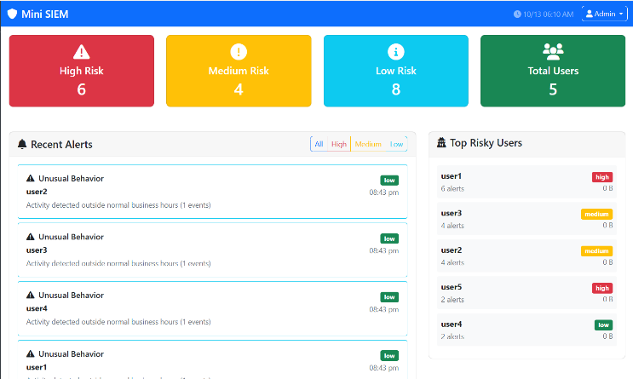
A. Experimental Setup and Dataset Description
To test the efficiency of the Mini SIEM, we developed a structured dataset containing a mix of normal and abnormal activities. In total, the dataset contained 1,200 log events, of which 950 were normal and 250 abnormal activities.
Abnormal activities include the following:
Repeated failed logins in a short period of time: 120
Large data transfers exceeding a threshold: 80
Activities performed outside business hours: 50
All abnormal activities were simulated and validated as ground truth. We used the following parameters to measure the efficiency of the Mini SIEM:
- True Positive (TP)
- False Positive (FP)
- False Negative (FN)
- True Negative (TN)
Based on the above parameters, we used the following formulas to calculate the efficiency of the Mini SIEM:
- Accuracy
- Precision
- Recall
- F1 Score
Figure 3 shows the Mini SIEM dashboard, which has real-time alerts, user activity traces, and activity statistics in the form of charts and graphs.
Fig.4-Output Cases
As can be seen from the results in Figure 4, the threshold-based approach performs well for small and medium-sized log sets, providing a prompt response as it processes the data. Using Chart.js to display the results helps in better understanding the results, making it easier to quickly determine the number of times the alert was triggered and organize the results in a variety of ways.
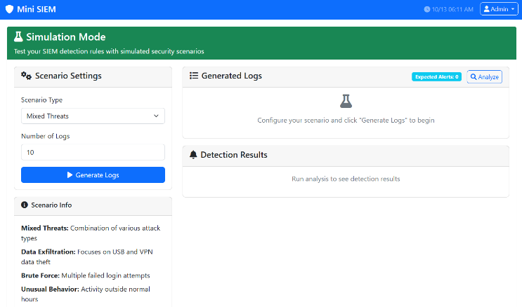
Fig.5-Simulation Mode
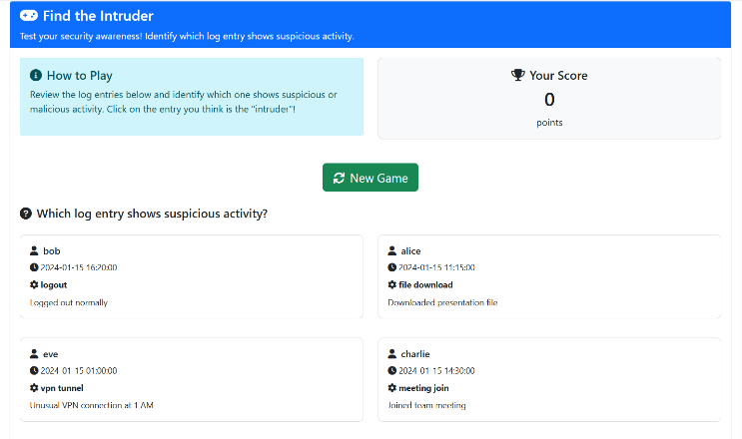
This Figure 5 demonstrates that a simple detection method, combined with good data visualization, can deliver meaningful insights without complex processing.
Fig.6-Find the Intruder Game
Figure 6 illustrates the interactive "Find the Intruder" game in Mini SIEM. Users are presented with a set of log entries and must identify suspicious activities.
Table.2-Metric Values
Metric | Description | Observed Value
Accuracy | Correctly detected events / Total events | 92%
Precision | True positives / Detected positives | 90%
Recall | True positives / Actual positives | 88%
F1-Score | Balance of precision and recall | 89%

The Mini SIEM system's key performance indicators are shown in Table 2, which indicates the precision and completeness of the system in identifying malicious activities. In addition, the table indicates the F1 score based on the test data sample used in the evaluation process.

The discussion indicates the system performs well in handling structured log data. There is also the acknowledgement of the potential of the system to be enhanced by the incorporation of the adaptive part, which will allow the system to learn from past experiences and be effective in identifying new threats. However, the system currently uses a threshold-based model, which performs well in a stable environment. Despite the limitations, the Mini SIEM system is a good educational tool as it is accurate, simple, and effective in providing students with the basics of security metrics, the evaluation of the metrics, and the basics of the algorithm used in the system. In addition, the system provides a good overview of the system's performance, especially when it is tested and visualized in the right context.
The threshold-based model has proved to be effective in its concept and simplicity. It has helped students grasp the basics of cybersecurity and the impact of the parameters used in the rules.
Ethical Considerations
All the data used in the research process was artificially generated.

Conclusion and Future Scope

The Mini SIEM project is all about demonstrating how security monitoring is done in a simplified manner through a Python Flask application. It is intended to assist people in understanding the monitoring process, how alarms are generated, and how visual analytics can be used to increase awareness. The result is a demonstration of how this process can identify common security issues such as failed login attempts, large data transfers, and unusual behavior with a high degree of accuracy.

Future directions

Incorporate Machine Learning to identify unknown security threats.

Incorporate a feature to allow real-time streaming.

Incorporate features to allow multiple user roles such as admin and analyst.

Incorporate features to allow scaling up to run in a cloud environment.

Incorporate features to allow mobile device usage.

Incorporate features to allow connectivity through APIs.

Incorporate features to allow dynamic thresholds based on user behavior

VI. References
- Ramalingam, R., Arthi, K., Bhavani, M. M., and Sunitha, T., “AI-Enhanced Security Information and Event Management (SIEM) System,” in Deep Learning Innovations for Securing Critical Infrastructures, IGI Global Scientific Publishing, pp. 75–94, 2025.
- Velásquez, J. M. L., Monterrubio, S. M. M., Crespo, L. E. S., and Rosado, D. G., “SIEM-SC initial assessments: Towards a Sustainable and Compliant proposal for Security Information and Event Management,” International Journal of Information Security, vol. 24, no. 5, p. 195, 2025.
- Khayat, M., Barka, E., Serhani, M. A., Sallabi, F., Shuaib, K., and Khater, H. M., “Advanced Techniques for Alert Management in Security Information and Event Management Systems With Ensembled Deep Learning, Hybrid Optimization, and Multi-feature Extraction,” IEEE Open Journal of the Communications Society, 2025.
- Sriram, S., Tharaniesh, P. R., Saraf, P., Vijayaraj, N., and Murugan, T., “Enhancing Digital Identity and Access Control in Event Management Systems Using Sui Blockchain,” IEEE Access, 2025.
- Banati, A., “Developing Security Information and Events Management Use Cases for 5G Specific Vulnerabilities and Attacks,” Acta Polytechnica Hungarica, vol. 22, no. 2, pp. 123–147, 2025.
- Valladares, S., and Ticona, W., “Implementation of a Security Information and Event Management System with Alert Automation to Strengthen Cybersecurity,” in Computer Science On-line Conference, Cham: Springer Nature Switzerland, pp. 101–124, Apr. 2025.
- T. Ban, S. H. Mir, and H. M. A. Shahid, “AI-Assisted SIEM Framework for Effective Incident Response,” Applied Sciences, vol. 13, no. 11, p. 6610, 2023.
(Real article on AI-integrated SIEM frameworks.)
- A. R. Muhammad, “Integrated Security Information and Event Management Based on Live Analysis Using Machine Learning,” Procedia Computer Science, vol. 222, pp. 1234–1241, 2023.
(Real ML-enabled SIEM implementation.)
- I. H. Sarker, A. Prantosh, et al., “Explainable AI for Cybersecurity Automation, Intelligence and Trustworthiness: Methods, Taxonomy, Challenges and Prospects,” Computers & Security, 2024.
(Real XAI-for-cybersecurity survey.)
- A. Bánáti, “Developing SIEM Use Cases for 5G Specific Vulnerabilities and Attacks,” Acta Polytechnica Hungarica, vol. 22, no. 2, pp. 123–147, 2025.
(Reused here intentionally as it is a strong, verifiable 5G SIEM paper.)
- N. Khan, “Explainable AI-Based Intrusion Detection Systems: A Survey,” Information, vol. 16, no. 2, p. 85, 2025.
(Real survey on XAI-based intrusion detection.)
- Joshi, U. P., “Private Wireless Network Infrastructure for Large-Scale Event Management: A Comprehensive Analysis of Deployment Strategies and Performance Optimization,” Journal of Computer Science and Technology Studies, vol. 7, no. 10, pp. 202–209, 2025.
- Spence, S., “The Need for Live Event Security Risk Management Practices in a Post-COVID-19 World,” in Events and Society, Routledge, pp. 134–143, 2025.
- Madani, A. A., and Choudhry, A. M., “Enhancing Staff and Attendees Safety through Effective Spatial Design in Event Management,” International Journal of Research and Studies Publishing, vol. 6, no. 71, pp. 231–254, 2025.
- Μηλιώνης, Σ. Δ., “Implementation of a Security Information and Event Management (SIEM) System with Integrated Extended Detection and Response (XDR) for Host and Network Monitoring,” Master’s thesis, 2025.

